

July 4, 2000

Baumbach Family Meeting / Reunion

September 9th 2000 Nentershausen Germany

To: All Baumbachs and their Descendants.

Did you know in Tannenberg Germany there is a Baumbach Castle dating back to the 1300’s?

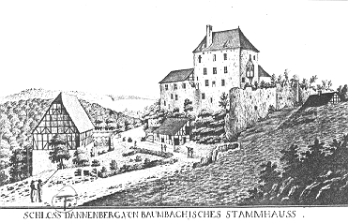
How might you be related? Genealogical research shows that in 1796 the King of Hessen sold soldiers to the King of England, who were then sent to fight in the American Revolution. Among the officers were members of the Baumbach family. Family members have also been documented as early settlers to Milwaukee.

The brothers, Friedrich-Wilhelm and Bodo von Baumbach of Germany have invited all Baumbach descendants and friends of the Baumbach Castle to join in a meeting / reunion on September 9th 2000 at the Baumbach Castle followed by a fundraising medieval dinner with period music at the Castle.

Join us in person to explore your Baumbach history going back thousands of years. In addition to seeing the Castle you will see items that have been in the Baumbach family for thousands of years such as paintings, chairs, bibles, dishes and much more.

The Castle is located in the little village of Nentershausen 150 miles north of Frankfurt near Eisenach, Bebra and Bad Hersfeld. To get to Nentershausen from the airport in Frankfurt take Autobahn nr 5 north to Kirchheim then turn right to the Autobahn nr 4 to "Wildeck-Obersuhl," then leave the Autobahn going left to Nentershausen about 6 miles. It is easy to get there by train from Frankfurt north to Bebra where we will pick you up by car.

Accommodations are available at the Guesthouses on the family homestead or in hotels in Nentershausen, Germany, just minutes away from the Castle.
R.S.V.P. to one of us below:
Friedrich-Wilhelm von Baumbach  Gutshof  36214 Nentershausen, Germany  Tel: 011 49 6627-553 Fax: 011 49 6627-8624 | William J. Baumbach II  2380 Mountain Road  Haymarket, Virginia 20169  Phone 703-791-9522
This notice has been mailed to about 600 Baumbachs which I found addresses for in the USA. If you are not interested in attending please forward this letter to a family member who may be interested as we may not have been able to notify them.

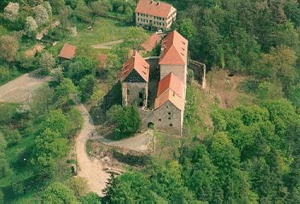
The Baumbach Castle
Built in about 1350 by Ludwig Baumbach a "Strikt Knight" in the 1700’s, the Baumbachs left the Castle since it had lost its meaning for defense because of the invention of the canon. They built several farms all over Germany after they sold most of their land in Nentershausen to the King. In about 1850 several Baumbachs immigrated to America. Over the last 300 hundred years the Castle has been falling apart, but there are still three main buildings that are worth restoring. Ten years ago the german state funded about one million dollars to restore it but since the reunion of East and West-Germany all the money goes to East-Germany which is much more destroyed then the West. So the rebuilding of the Castle had to be stopped or slowed down. Now, most of the work is done by the friends of the Castle and the farm-workers of Friedrich von Baumbach. The Castle is popular in Germany and is visited by many vacationers and tourists.

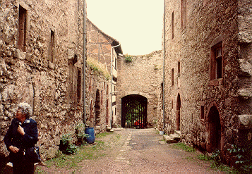
Preserve your family history for generations.
Having to withstand the elements over many thousands of years the condition of the Castle is starting to deteriorate and is in desperate need of repairs. With no forthcoming funds from the german state the Baumbachs and friends of the Castle in the USA and Germany have formed a non-profit Association called The Friends of Tannenberg an association dedicated to preserving and restoring the Castle. In becoming a member you would help this Association to restore and preserve the Castle by raising money and keeping it a historical monument to all Baumbachs and friends for generations to come.

There will be details posted on my website as it becomes available. You can also see pictures of the Baumbach Castle and town at www.Baumbach.com/History

My brother Andy and myself with other family members are making plans to be there for the Baumbach Worldwide Family Reunion and hope to see many fellow Baumbachs there.

Please contact me for more information about the meeting or Association if you want to be put on our mailing list.

Sincerely;


William J. Baumbach II
2380 Mountain Road
Haymarket, Virginia 20169
Phone 703-791-9522
William@Baumbach.com / www.Baumbach.com

